Aim: - To implement and observe output of Random Forest on IDLE.

CODE: -

import pandas as pd

import matplotlib.pyplot as plt

import seaborn as sns

from sklearn.model_selection import train_test_split

from sklearn.preprocessing import RobustScaler

from sklearn.model_selection import train_test_split

from sklearn.ensemble import RandomForestClassifier

from sklearn import metrics

Bill_Auth_data = pd.read_csv('bill_authentication.csv')

print(Bill_Auth_data.head())

print(Bill_Auth_data.info())

Bill_Auth_data = Bill_Auth_data.sample(frac=1.0).reset_index(drop=True)

print(Bill_Auth_data.head())

print(Bill_Auth_data.describe())

Bill_Auth_data.iloc[:,0:-1].plot(kind='hist',subplots=True,layout=(2,2),figsize=(15,6));

Bill_Auth_data.iloc[:,0:-1].plot(kind='box',subplots=True,layout=(2,2),figsize=(15,6));

sns.pairplot(data=Bill_Auth_data,hue='Class');

X = Bill_Auth_data.drop('Class',axis=1)

Y = Bill_Auth_data['Class']

RS = RobustScaler()

X = RS.fit_transform(X)

X_train, X_test, Y_train, Y_test = train_test_split(X,Y,test_size=0.2,random_state=10)

RFC = RandomForestClassifier()

RFC.fit(X_train,Y_train)

Y_pred = RFC.predict(X_test)

print(metrics.accuracy_score(Y_test,Y_pred))

print(metrics.confusion_matrix(Y_test,Y_pred))

print(metrics.classification_report(Y_test,Y_pred))

accuracy_list =[]

for n_est in range(50,201,10):

RFC = RandomForestClassifier(n_estimators=n_est)

RFC.fit(X_train,Y_train)

accuracy_list.append(round(metrics.accuracy_score(Y_test,RFC.predict(X_test))*100,2))

plt.figure(figsize=(12, 6))

plt.plot(range(50, 201, 10), accuracy_list, color='red',linestyle='dashed', marker='o', markerfacecolor='blue',markersize=10)

plt.xticks(range(50, 201, 10))

plt.xlabel('n_estimator Value')

plt.ylabel('Accuracy');

plt.show()

Output: -

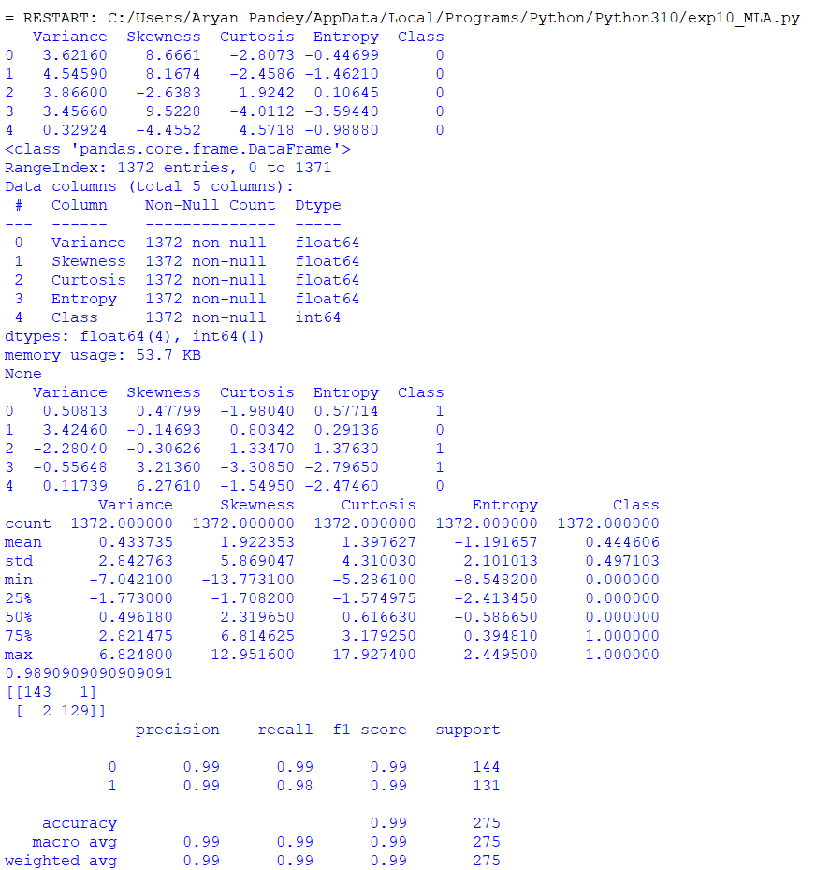

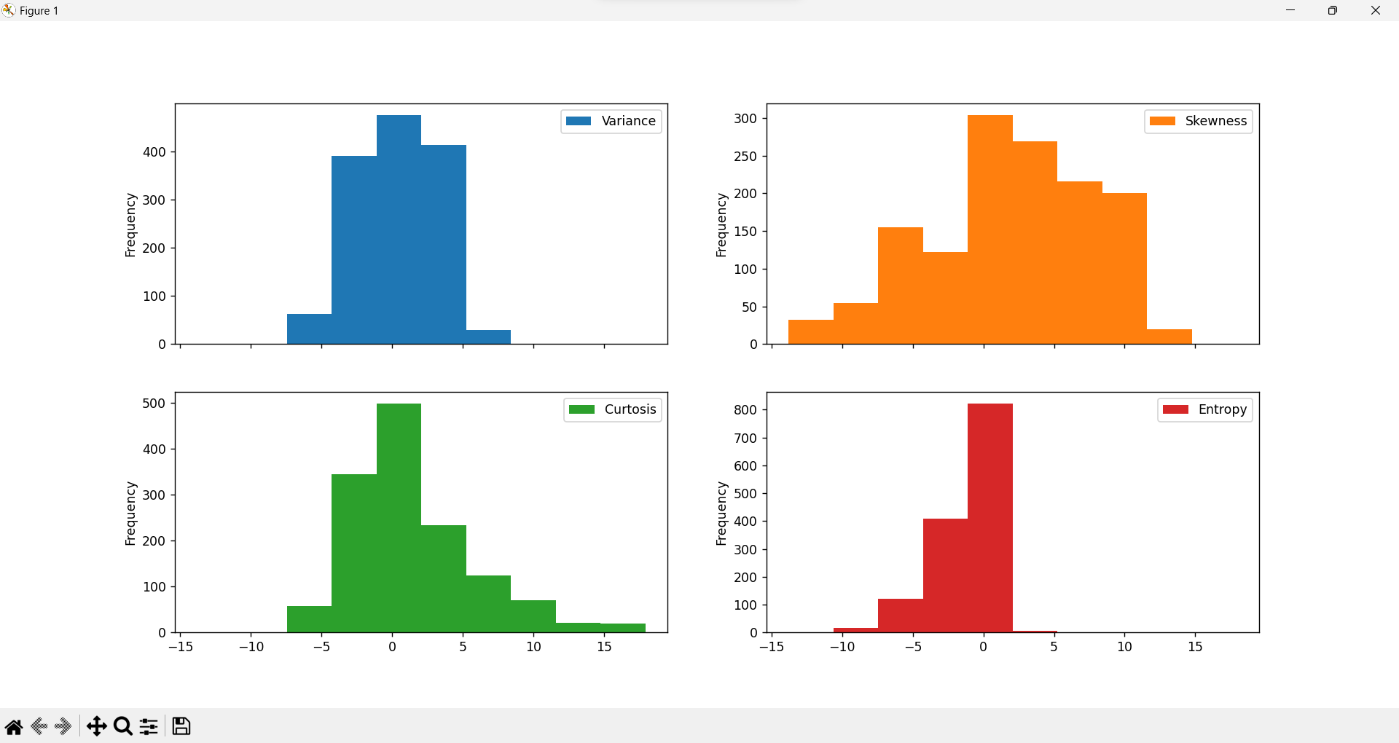

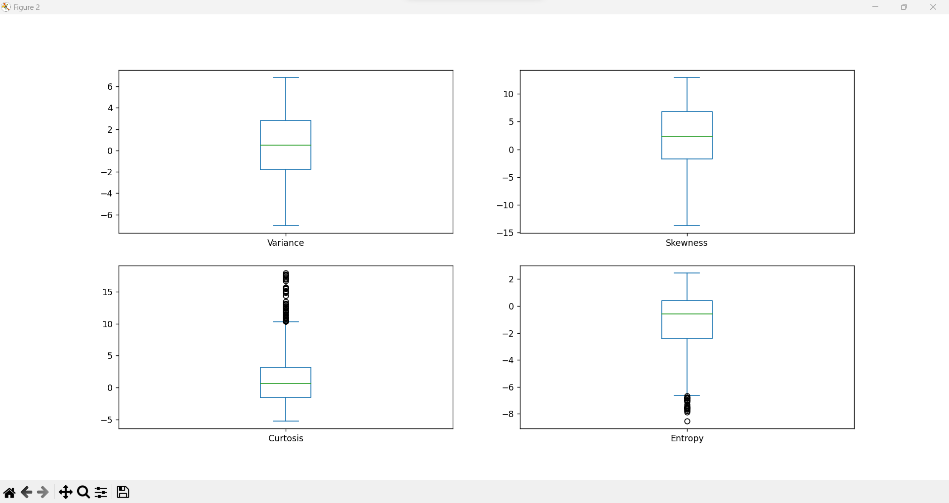

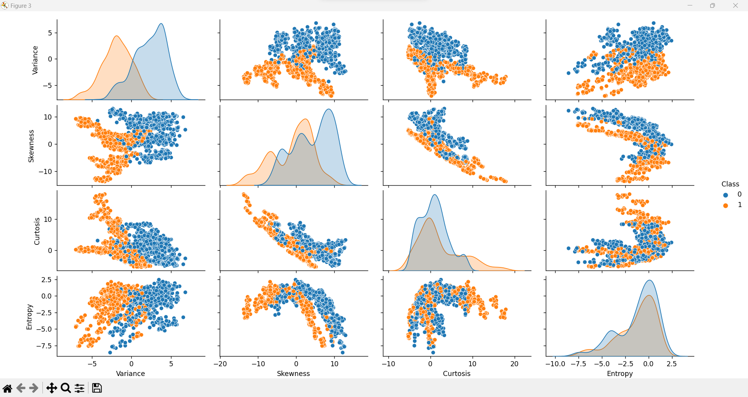

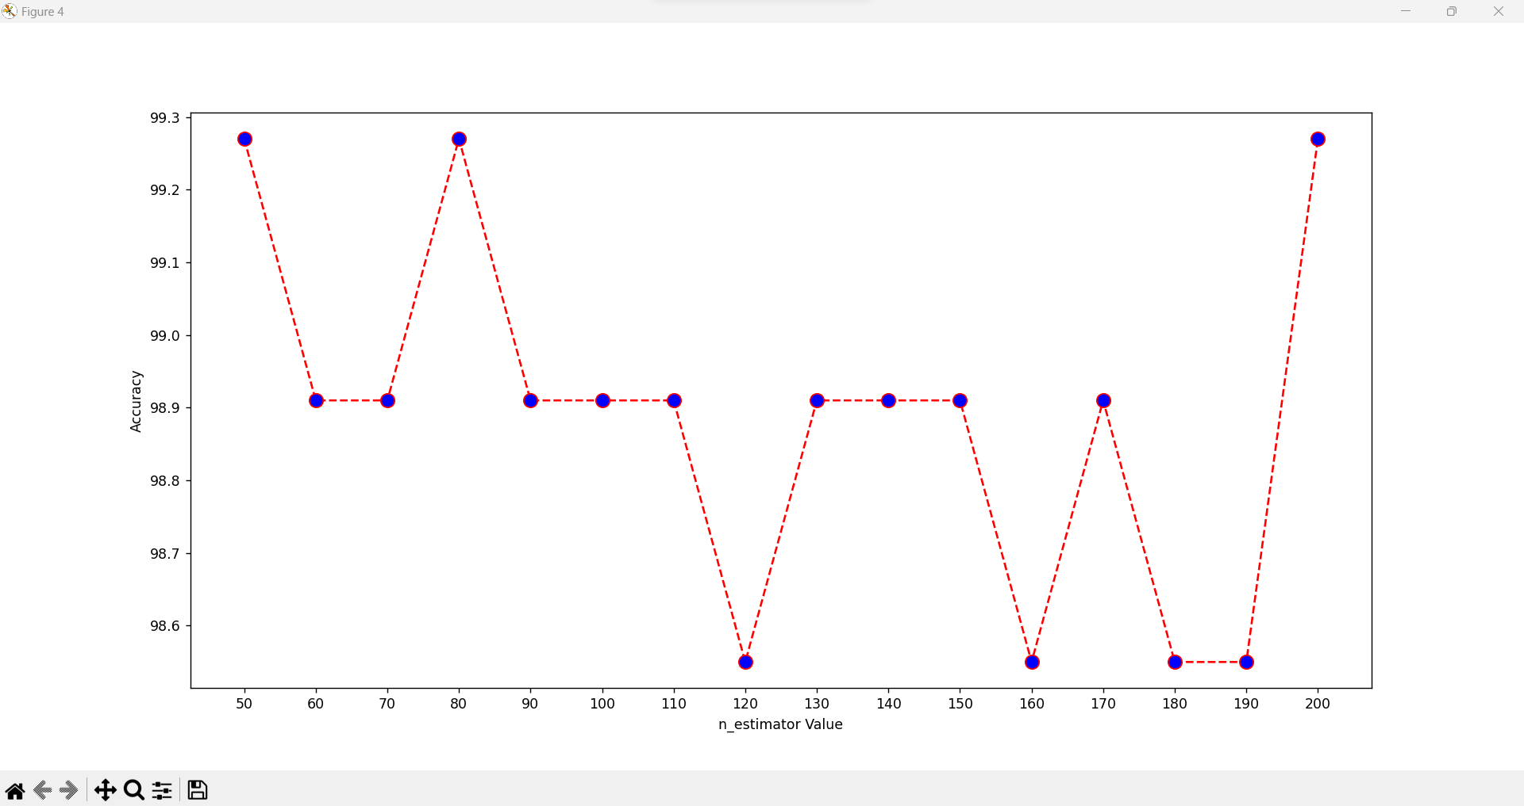

Result: -

Hence verified and got the output of the tasks on IDLE Python.